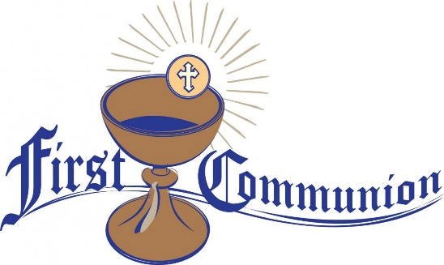

REQUIREMENTS FOR THE PROGRAM

1) It requires the commitment of parents to collaborate at home with the formation in the faith of their children; to pray as a family and to participate in Sunday Mass.

2) The child must be at least 8 years old and in grades 2-8.

3) Present the Baptism Certificate and if you have not been baptized, present the Birth Certificate (Without these documents we cannot register)

4) Registration fees:

First Communion | $ 200
Confirmation (High School) | $200
RCIA – Adult Confirmation | $200
RCIC | $200
Continuing Education | $50

PROGRAM (We will start in October)

• Our Program is only one year for First Reconciliation and First Communion.

- Parent's Roll

As the primary educators of our children it is the parent's responsibility to be involved with your children in the sacramental life of our parish, to participate in Mass regularly (every Sunday), to pray with your children and help them grow in relationship with God. Participation in the program also implies the participation in all parent meetings (mandatory meetings twice a month: calendar will be provided); as well as teaching your child at home with the activities; as well as helping your children understand and memorize basic sentences.

- Participant’s roll

All participants in Saint Leo Parish program are responsible for creating and maintaining a positive experience for everyone. We are all expected to be respectful of each other, to listen and follow the directions of those in charge and participate fully in all activities.

• In person and Virtual Catechesis
+ We meet on Saturdays with two schedules (Pick one of the following times):
a) 9:45 AM to 11:00 AM
b) 11:30 AM to 12:45 PM
c) Attendance and punctuality are essential.
+ For the moment we will start catechesis online; Twice a month we will give them material to work at home, as a complement to what they have learned online.
+ Catechesis is bilingual, English and we have a group in Spanish.
- Order and discipline in the classrooms

It is very important to be on time to class and if for some reason your child can not attend, please call the catechists, the director or the parish office. To maintain clean classrooms, any food and drinks are not allowed. Chewing gum in the classroom or in the school hallways are not allowed! We ask the children respect for catechists and attention to all the instructions are given.
If you attend a Zoom, you need to be present and visible. Not a blank screen or a picture of yourself. You need to be visible from at least the eyes up. Even though we are not in the classroom, the classroom rules apply.

TO RECEIVE COMMUNION

• Parents' attendance and punctuality at assigned meetings.
• Children's attendance and good behavior in person or virtual classes.
• Complete and turn in all assigned activities on time.
• Final approval of the Catechist regarding the understanding and complete preparation of the child. Complete list of requirements signed and approved by the catechist.

UNBAPTIZED CHILDREN

• The model and requirements are the same.
• These children will be prepared to be received into the Catholic Church, so they will participate in some special celebrations on Sundays during Lent.
• After receiving the sacraments during the Easter Vigil, they are asked to continue their catechesis to prepare for the Sacrament of Confession.

YOUTH CONFIRMATION

• For teens who are baptized and who are in grades 9-12 in High School.
• Present the Baptismal Certificate, pay the registration fee and fill out the form.

GODPARENTS
• A Catholic sponsor is required, over 16 years of age and who has the sacraments of Baptism, Confirmation and Communion. May he be a good example of Catholic life. Someone who is committed to guiding the young person and being supportive of the young person's faith.

PROGRAM DESCRIPTION

• Confirmation catechesis is in English, on Saturdays and with the same times as the First Communion program.
• In person and virtual: for this program the young people must commit to following the instructions of the Catechists and if any young person does not obey, they will be left out of the program.
• Parents will be asked to participate in a mandatory monthly catechesis.
• Young people are asked to participate in Sunday Mass.
• We will include assigned tasks and projects.
• They will be asked for community services and activities, which they can do at St Leo's Church.

• Zoom Directions:
Headphones help with background noise!
1. Click on the meeting link your teacher sends or posts.
2. When your teacher joins the meeting, the virtual room will pop up. You may have to wait to be admitted to the room.
3. Join a meeting with your sound muted.
4. If your teacher invites you to speak, a message may or may not pop up.
5. First names only on the screen.
6. If you attend a Zoom, you need to be present and visible. Not a blank screen or a picture of yourself. You need to be visible from at least the
eyes up.
7. Private chats or texts are not allowed during class Zoom meetings.
8. Have everything handy that you might need for the Zoom meeting (paper, pencil, textbook etc.).
9. Even though we are not in the classroom, the classroom rules apply

CATHOLIC CHURCH
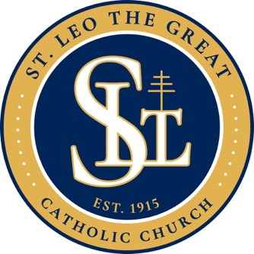

FAITH FORMATION
Sacramental Preparation
2020-2021

Baptism
Confirmation
Eucharist
For
Children and teenagers

St Leo Church
88 Race Street,
San Jose, CA., 95126

(408) 293-3503 Extension 407

www.stleochurchsj.org
nidia.fuentes@dsj.org

